Assignment 4
Module: Fundamentals of Data Science
Student Name: Sizone Giri

Program 1:

Description of the Program:

A program to create a null vector of size 10 but the fifth value which is 1.

Source Code:
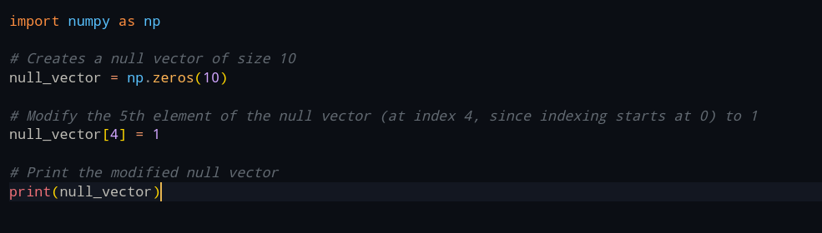

Output Screenshot:
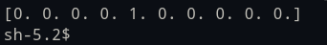

Program 2:

Description of the Program:
A program to ask the user to input two numbers a, b.
and generates a random array of shape (a, b) and
prints the array and avg of the array
Source Code:
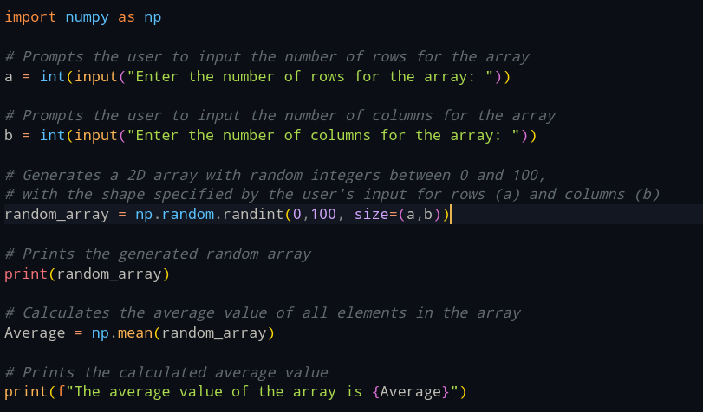

Output Sceenshot:
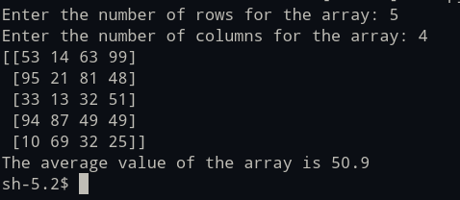

Program 3:

Description of the Program:
A program to create a vector of size 10 with values ranging from 0 to 1, both excluded.

Source Code:
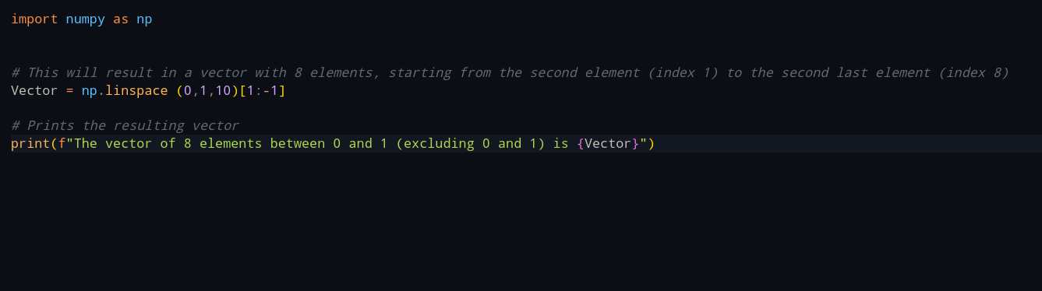

Output Screenshot(s):

Program 4:

Description of the Program:
A program to create a identity matrix of shape (3,4).

Source Code:
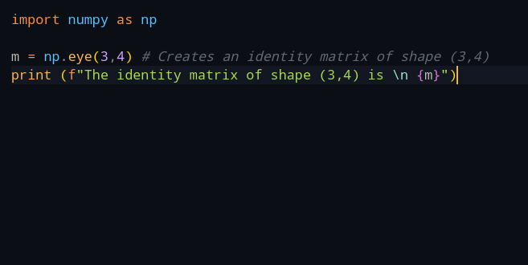

Output Screenshot:
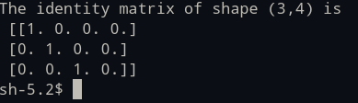

Program 5:

Description of the Program:
A program to create a 5x5 matrix with row values ranging from 0 to 4

Source Code:
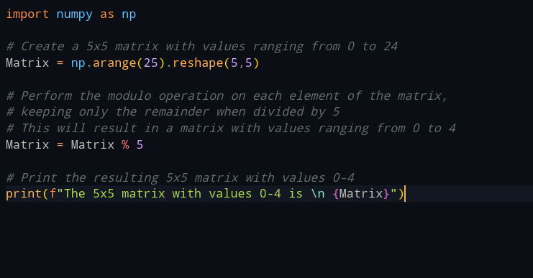

Output Screenshot:
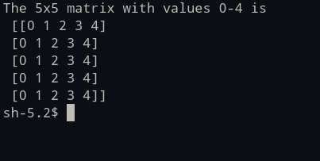

Program 6:

Description of the Program:
A program with Pandas module to add, subtract, multiple and divide two Pandas Series.

Source Code:
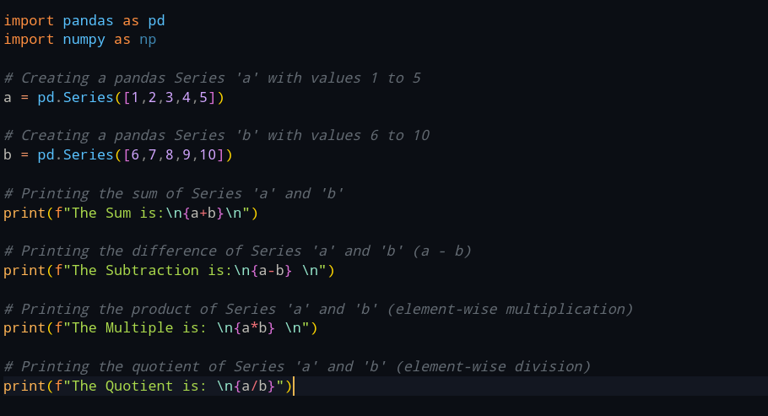

Output Screenshot:
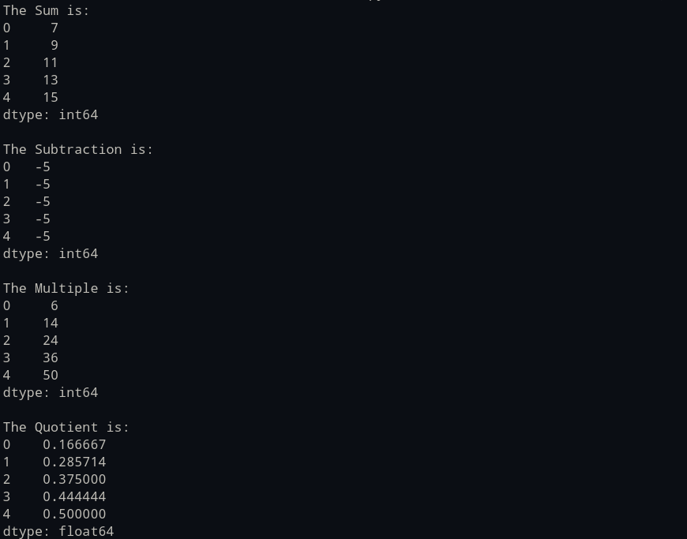

Program 7:

Description of the Program:
A program to create an array of random integer numbers as a numpy array, and do the following:

#sort them and perform operations such as reshaping of the array into matrix of feasible dimensions.
#(e.g., if we have an array of 1 * 10, then we can reshape it into 2 * 5 or 5 * 2 matrix.
Source Code:
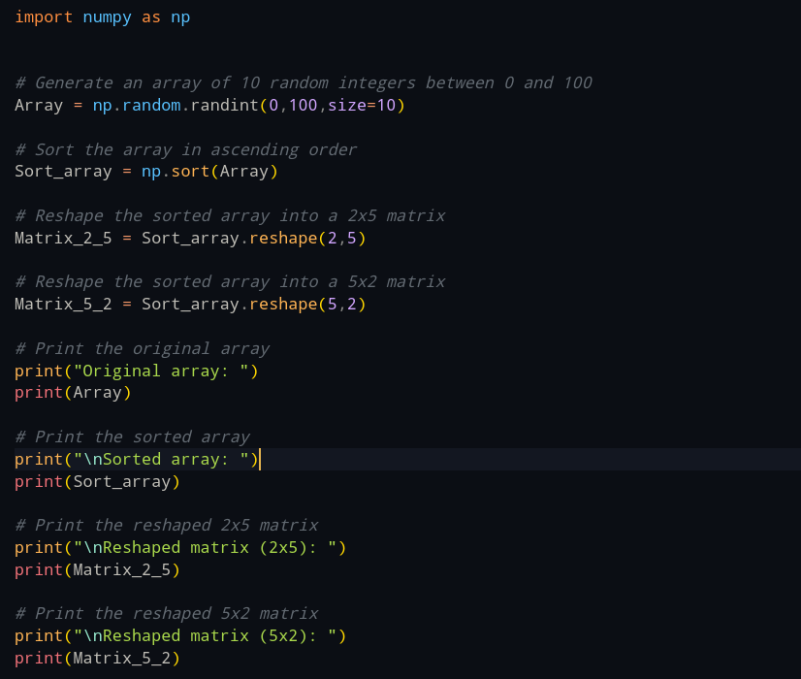

Output Screenshot(s):
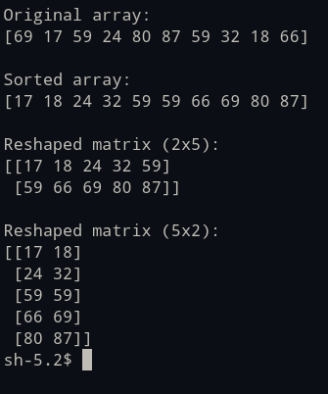

Program 8:

Description of the Program:
A program to input an array of numbers from the user (at least 10 elements in list) and sorts them and performs slicing operations to get elements between indexes such as 2-5, 5-8, 2-9.

Source Code:
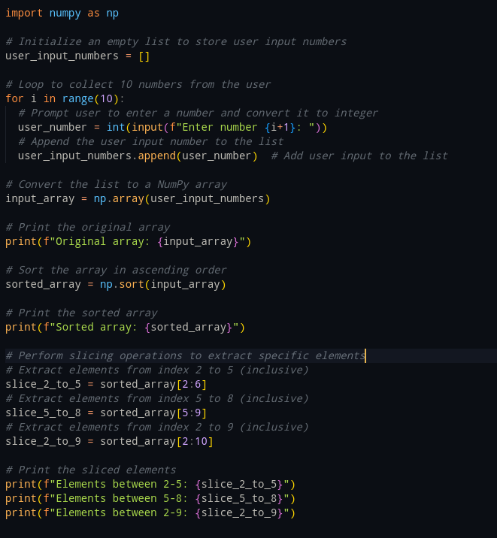

Output Screenshot:
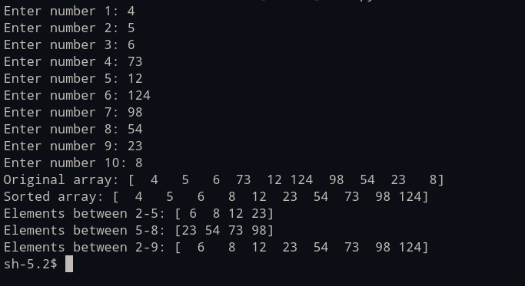

Program 9:

Description of the Program:
A program that does the following:
a.Write a query to select only the Name and Salary columns.
b.How would you filter out all employees in the "IT" department?
c. Write code to select employees who are older than 30 and find the average salary of employees in each department.
d.Write code to count the number of employees in each department.
e.Add a new column Bonus which is 10% of each employee's salary.
f.Replace all occurrences of "HR" in the Department column with "Human Resources."
g.Find the employee(s) with the longest tenure (based on JoinDate).
h.Create a new column SalaryCategory where salaries above 75,000 are categorized as "High" and the rest as "Low."
i. Write a program to check if there are any duplicate EmployeeIDs and remove them if found.
j.Use Pandas to calculate the median Age of all employees.

Source Code:

import pandas as pd
import numpy as np

# Define employee data
employee_data = {
"EmployeeID": [101, 102, 103, 104, 105],
"Name": ["John Smith", "Alice Brown", "Bob White", "Emma Green", "Charlie Red"],
"Department": ["IT", "HR", "IT", "Finance", "HR"],
"Age": [30, 28, 35, 40, 25],
"Salary": [70000, 60000, 80000, 90000, 55000],
"JoinDate": ["2018-07-15", "2020-03-10", "2016-11-01", "2012-05-25", "2021-06-01"],
"ExperienceYears": [5, 3, 7, 11, 2]
}

# Create a DataFrame from the employee data
df = pd.DataFrame(employee_data)

# **a. Select Name and Salary columns**
name_and_salary = df[["Name", "Salary"]] # Select only the Name and Salary columns
print(f"Name and Salary columns:\n{name_and_salary}\n")

# **b. Filter IT department employees**
it_employees = df[df["Department"] == "IT"] # Filter employees in the IT department
print(f"Employees in the IT department:\n{it_employees}\n")

# **c. Calculate average salary for employees older than 30**
older_than_30 = df[df["Age"] > 30] # Select employees older than 30
avg_salary_older_than_30 = older_than_30.groupby("Department")["Salary"].mean() # Calculate average salary for each department
print(f"Average salary of employees older than 30:\n{avg_salary_older_than_30}\n")

# **d. Count employees in each department**
department_counts = df["Department"].value_counts() # Count employees in each department
print(f"Number of employees in each department:\n{department_counts}\n")

# **e. Calculate bonus for each employee**
df["Bonus"] = df["Salary"] * 0.10 # Calculate 10% bonus for each employee
print(f"Bonus for each employee:\n{df[["Name", "Salary", "Bonus"]]}\n")

# **f. Replace HR with Human Resources in Department column**
df["Department"] = df["Department"].replace("HR", "Human Resources") # Replace HR with Human Resources
print(f"HR replaced with Human Resources in Department column:\n{df[["Name", "Department"]]}\n")

# **g. Find employees with longest tenure**
df["JoinDate"] = pd.to_datetime(df["JoinDate"]) # Convert JoinDate to datetime format
longest_tenure = df[df["JoinDate"] == df["JoinDate"].min()] # Find employees with longest tenure
print(f"Employees with longest tenure:\n{longest_tenure[["Name", "JoinDate"]]}\n")

# **h. Create SalaryCategory column**
df["SalaryCategory"] = df["Salary"].apply(lambda x: "High" if x > 75000 else "Low") # Create SalaryCategory column
print(df[["Name", "Salary", "SalaryCategory"]], "\n")

# **i. Check for duplicate EmployeeIDs**
if df["EmployeeID"].duplicated().any(): # Check for duplicate EmployeeIDs
df = df.drop_duplicates(subset="EmployeeID") # Remove duplicate rows
print("Duplicate ID has been removed")
else:
print("No Duplicate ID are found.")

print(df[["EmployeeID", "Name"]], "\n")

# **j. Calculate median age**
median_age_value = df["Age"].median() # Calculate median age
print(f"Median age of all employees is: {median_age_value}\n")

Output Screenshot:
